ENGLISH GUIDE 2NM - TP
Liceo de Adultos Pucará de Chena
English Department
Teacher: PabloRodriguez.
Francisco Hernández Murga Jonathan Villalobos

NOTA

Name:________________________________________________________________
Date: _____________________________
Grade: ____________________________

Objetivo: Comprender e interpretar textos escritos de carácter narrativo de mayor complejidad lingüística y temática identificando información principal y secundaria.

- Read the text. (Lea el texto)

“A success story “ ( by Susan Slim from California )

“All during my childhood I was teased by my peers because I was overweight. Although I was never obese, I was larger than my classmates and their words made me angry and depressed. Instead of talking to my parents and teachers about my feelings though, I turned to food to comfort myself.

My turning point came when I was a teenager and I went to the doctor for a physical exam. The doctor told me that being overweight put me at risk for high blood pressure, heart disease, diabetes and other health problems that could cost my life.
I was frightened by this prognosis. I realized that I didn’t want to die so young and I decided to make an effort to lose some weight.

I started a weight loss program. Through it I learned how to add healthful eating habits to my life. I switched from whole milk to skimmed milk, reduced my portions of food, drank more water, and added fruits and vegetables to my diet.

I continued with my diet but my weight was always fluctuating. During the Summer I would lose about 10 kilograms only to gain them in the Winter. My self-esteem then was lower and lower and I had come to accept that I would be a yo-yo dieter for the rest of my life. But then something happened. I was under a tremendous amount of stress from my work when a friend mentioned how exercise helped to deal with stress.

So that’s how I started exercising: stair climbing, jogging, walking, 3 or 4 times a week. Almost immediately it helped me reduce my stress and have more energy.

Along the way I have learned that fitness and well being come from the inner self and not just from the reflection on the mirror. That’s why I want to share my successful experience with you. Hope it works out!

Here’s my workout schedule:

- • Elliptical training, jogging, walking, step aerobics or biking 1 hour/ 3 or 4 times a week.
- • Strength training: 40 minute/ 3 times a week.

Maintenance Tips

- • Drink water. Not only does it fill you up. It also cleans your body.
- • Eat six small meals a day rather than three larger ones. This way you are never hungry.
- • Once a week, enjoy your favorite food so that you don’t feel deprived!

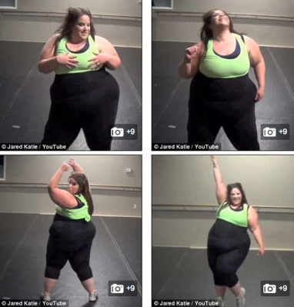

2. Read the text and circle the best answer (1 point)

What is the text about?

a. Una joven que lucha toda su vida por perder peso.
b. Una joven que está en peligro de muerte.
c. La importancia del ejercicio para los jóvenes.
3. Answer the following questions in English (8 points)

- Why did the young woman suffer when she was a child?

- What risks did she have because of her overweight according to the doctor?

- What eating habits did she change in order to lose weight?

- What two suggestions from the list do you consider the most important?

4. Write two consequences of being overweight mentioned in the text: (2 pts)

a. ___________________________________________________________

b. ___________________________________________________________

5. Write a list of your healthy eating habits. (At least 4 items). (8 points)

1- ___________________________________________________________
2- ___________________________________________________________
3- ___________________________________________________________
4- ___________________________________________________________

