ENGLISH WORKSHEET 1 ST LEVEL

Unit 2: ALL ABOUT YOU

Name: | Grade: | Mark:
Date: | Score: / 80 pts. | GOOD LUCK!!!

Aprendizajes esperados:
- Reconocer Verbo to Be en Afirmativo, negativo e Interrogativo.
- Practica de descripción física de un personaje.

- Complete each sentences using AM, IS, ARE
( Completa cada oración usando AM, IS, Are) 8pts

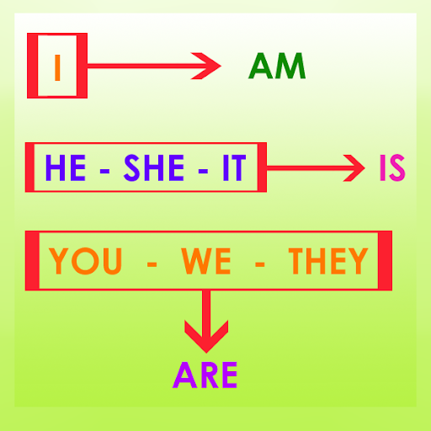
- I _________ a student.
- Barbara ________ happy.
- We ________ teachers.
- They ________ fine.
- He ________ play in the garden.
- You ________ my best friend.
- It ________ her dog.
- Tamara and Juan ________ doctors.

2. Fill in the blanks with am, is or are.
(Llena los espacios vacíos con AM, IS, ARE) 9 pts.

Hello, I _____ Naruto. I ______ twelve years old. I ________ a student. There ___ three people in my family. My mother ________ a nurse. She _______ forty years old.
My father ______ a doctor. I have a small dog. It ________ Lu. We ________a happy family.

- Change into interrogative form
(Cambia las oraciones a su forma Interrogativa) 8 pts

- She is going to school. _________________________________
- They are twelve years old. ________________________________
- You are tall. ________________________________
- It is his pen.
________________________________
- Marie is French.
_________________________________
- We are from Vietnam
_________________________________
- Juan and Hugo are friends.
_________________________________
- This is a chair
_________________________________
- Change the sentences into negative form.
(Cambia la forma de la oración a negativa) 10 pts

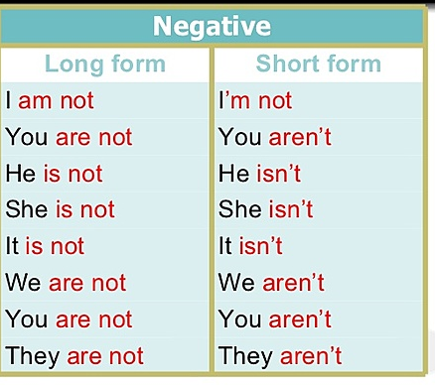
- I _________ a student.
- She ________ happy.
- We ________ teachers.
- They ________ fine.
- He ________ having dinner.
- You ________ my best friend.
- It ________ her dog.
- Julieta ________ tall.
- Tamara and Juan ________ doctors.
- I ________ tired.

- Correct the following mistake and Re-write again.
(Corrige los siguientes errores y re escribe la oración) 8 pts.

a) She am tall. ____________________________________________

b) It are an amazing chair_____________________________________________
c) You is the best classmate in the world._________________________________
d) I is the best brother in the world _________________________________________
e) Selena are singer in that park.___________________________________________
f) They is from Ucrania._________________________________________________
h) We is from Germany._________________________________________________
i) Carlos am talkative student._____________________________________________
6. Practice. In this picture you must write 9 sentences to describe this character. Remember first you have describe using IS and then HAS GOT.
(Practica. En esta foto tú debes escribir 9 oraciones para describir este personaje)
Recuerda, primero tú tienes que describir usando IS y luego HAS GOT
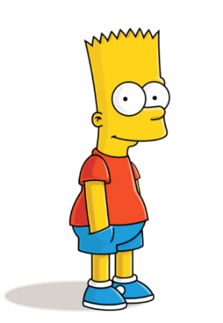

- ________________________________________________________________
- ________________________________________________________________
- ________________________________________________________________
- ________________________________________________________________
- ________________________________________________________________
- ________________________________________________________________
- ________________________________________________________________
- ________________________________________________________________
- ________________________________________________________________

- Try this One by yourself.
( Ahora intenta tu solo describir a este personaje)
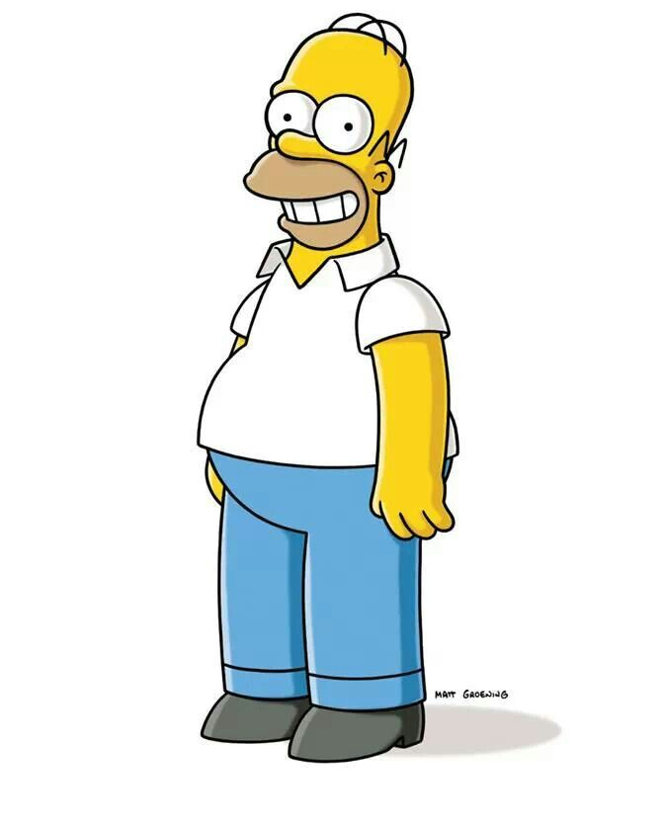

- ________________________________________________________________
- ________________________________________________________________
- ________________________________________________________________
- ________________________________________________________________
- ________________________________________________________________
- ________________________________________________________________
- ________________________________________________________________
- ________________________________________________________________
- ________________________________________________________________

AUTOEVALUACIÓN

Lee atentamente las preguntas y contesta con absoluta sinceridad.
¡Tu opinión nos importa!

¿Cómo te sentiste realizando esta guía? Señala si la encontraste muy difícil o no, ¿Por qué?
¿Siento que estoy aprendiendo con las guías realizadas este año (vía digital)?
¿Cómo te gustaría que fueran las siguientes guías?
¿Qué nota me pondría por haber realizado esta guía?

