ENGLISH WORKSHEET 2 ND LEVEL

Unit 3: ENTERTEINMENT

Name: | Grade: 2nd Level | Mark:
Date: | Score: / 50 | GOOD LUCK
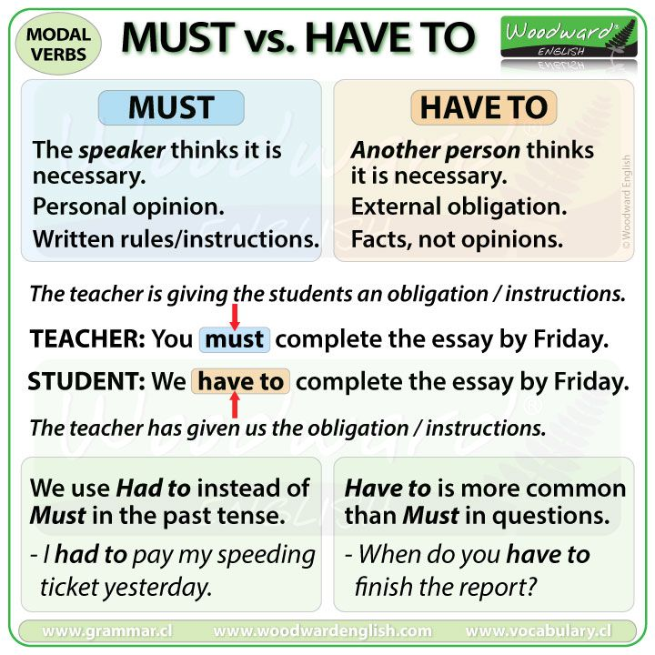
Aprendizajes esperados: Comprender y ejercitar los verbos modales MUST VS HAVE TO

- MUST
We use “Must” to talk about personal obligations. When we say I must, it’s something that I feel. When we say You must, it’s a personal opinión, not a rule or a law.

(Usamos Must para hablar de obligaciones personales. Cuando decimos I must, es algo que siento. Cuando decimos You must, es una opinión personal, no una regla o una ley).
Example: You must come visit me when you’re in town. (Debes venir a visitarme cuando estés en el pueblo)
- HAVE TO
We use “Have to” to talk about external obligations. When we say I have to or You have to, we refer to rules and the law. If you don’t do that, There will be a consequense.

(Usamos “Have to” para hablar de obligaciones externas. Cuando decimos I have to o You have to, nos referimos a reglas y la ley. Si no lo haces, habrá una consecuencia).
Example: You have to get a visa if you want to work in Australia. (Tienes que tener una visa si quieres trabajar en Australia).

- Complete the sentences using Have/Has to or Must if it corresponds. (16 pts.)
(Completa las oraciones usando “Have/Has to” or “Must” si corresponde)

- I ________________ shave, because if not, my boss will get angry with me.
- You ________________ get up early because it is Good for your health.
- My father _______________ pay the electricity Bill by Friday.
- I ________________ pass my final exam or my parents will get angry if I fail it.
- She ________________ tidy up her room because she doesn’t like sitting in a messy room.
- Kate __________________ buy a computer because it will be useful for her job.
- Children _____________________ make their beds every morning. It is great for them to know how to do it.
- People ___________________ eat vegetables. It’s good for them.

- Choose the correct alternative. (8 pts.) (Elige la alternativa correcta)

- She mustn’t/doesn’t have to wear casual clothes at school, because it is against the school regulation.
- He mustn´t/doesn’t have to drive a car because he is just 16 years old.
- We mustn’t/don’t have to pay extra money for using the swimming pool. It’s free.
- You mustn’t/ don’t have to wait for me, if you want you can go.
- Andrew mustn’t/ doesn’t have to enter a pub, because he isn´t over 18.
- You mustn’t/don’t have to take a photo in a museum, because it’s prohibited.
- Lucy mustn’t/doesn’t have to work because she is married to a millionaire.
- They mustn’t/don’t have to travel without Passport and Visa.

- Create sentences using Must or Have to, according to the immage. (12pst.)
(crear oraciones usando “Must” o “Have to” de acuerdo a la imagen)

A | B | C 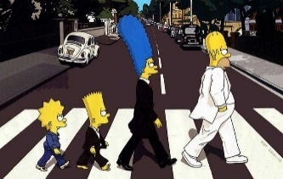
D | E | F

- _________________________________________________________
- _________________________________________________________
- _________________________________________________________
- _________________________________________________________
- _________________________________________________________
- __________________________________________________

- Find those words in the Word search (8 pts)
( Encuentra estas palabras en la sopa de letras)
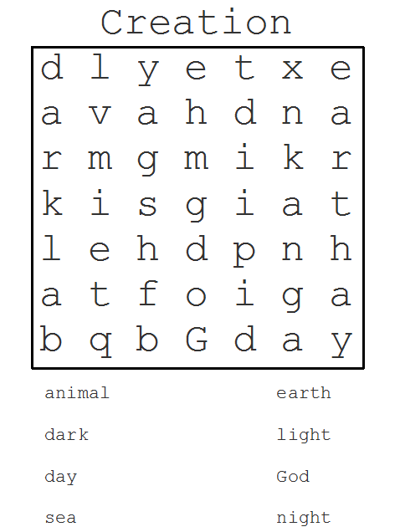

Destrezas | Niveles de desempeño
Inglés | Excelente  (35 a 42 pts.) | Bueno  (26 a 34 pts.) | Medianamente Logrado  (19 a 25 pts.) | Por Logar  (24 o menos pts.)
Utilización de verbos modales “Must” y “Have to” | Comprende y diferencia los verbos modales “Must” y “Have to” y los aplica correctamente en ejercicios escritos. | Utiliza apropiadamente los verbos modales “Must” y “Have to”, presentando ciertos errores de tipo gramatical | Presenta cierta dificultad para comprender y escribir oraciones, por lo que comete algunos errores de escritura. | No comprende ni diferencia los verbos modales. Respondiendo de forma errónea en la mayoría de preguntas y ejercicios.

